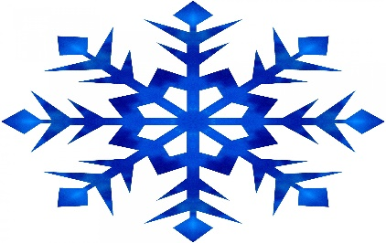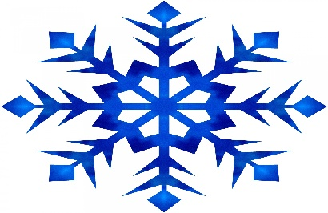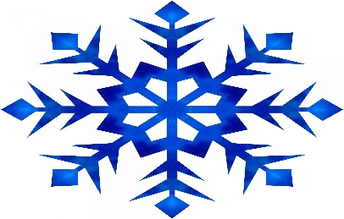
SOCIAL SKILLS SNOW POLICY
If the Cedar Rapids School District cancels school or releases school early due to weather, Tanager Place Social Skills Group will not meet that evening. Social Skills Coaches will post the announcement on the Tanager Place Social Media and with local television stations.
Thank You
Social Skills Staff
